Unit 1: Activity 5 Unravel the anagrams

SOIALC DISINGCNAT | 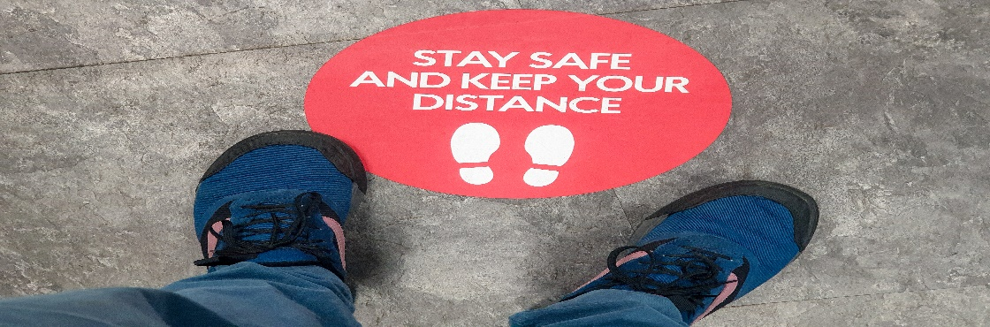
EFCA SKMAS

PRENOSLA HGYIENE

INGSTET

FLSE-LATIOSLNO

INESVACC | 