Unit 1: Activity 3 Case Studies

Individual A  Oliver, 16 year old White British male. No known underlying health conditions. | 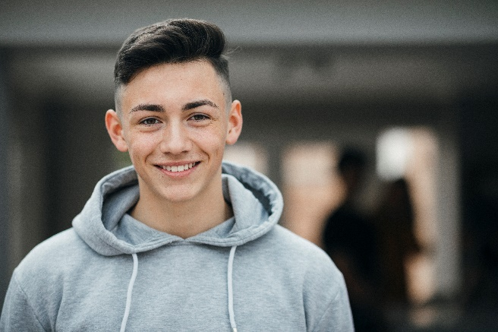
Individual B  Naomi, 24 year old Black British female. No known underlying health conditions. | 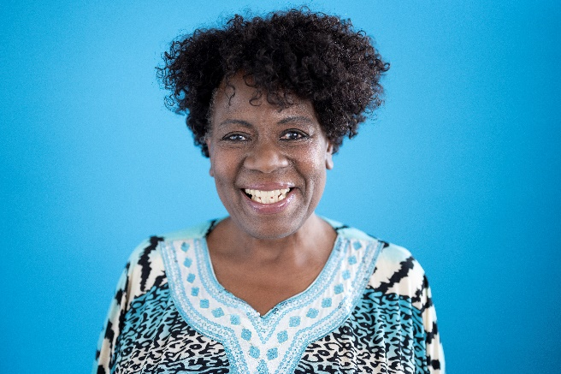
Individual C  Maureen, 75 year old White British female. Takes regular pain relief for arthritis. | 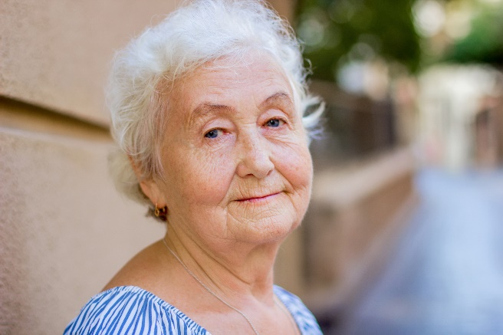
Individual D  Aran 14 year old Asian British male. Has Type 1 diabetes and uses insulin injections | 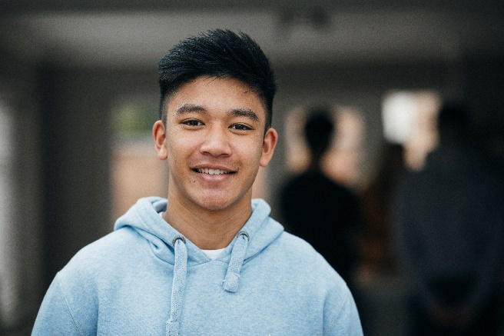
Individual E  Noah, 11 year old White British male. Is currently undergoing chemotherapy for leukaemia | 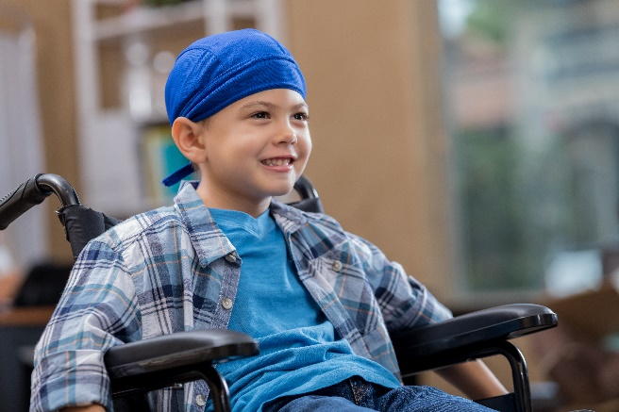
Individual F

Brian, 55 year old White British male. Is classed as overweight and has been diagnosed with heart disease

