Work experience pack for students

This pack contains guidance on applying for work experience in the Faculty of Medicine and the documents you will need to provide as part of your application.

The Faculty of Medicine oﬀers work experience opportunities to students:

* aged 14 or above
* in the last two years of schooling or while studying for A level or equivalent qualiﬁcations
* considering science, medicine or allied health profession as a possible career

It is important to us to oﬀer work experience to students in an equitable, open and transparent way. We take our safeguarding and health and safety obligations seriously.

**The University’s work experience guidelines can be found** [**here.**](https://www.southampton.ac.uk/assets/sharepoint/intranet/hr/How%20to/Guidelines%20-%20Work%20experience.pdf)

Included in this guide:

1. Faculty of Medicine work experience process and flow chart
2. Faculty of Medicine work experience request form

Work experience process and flow chart

The first step is to identify a supervisor to support your work experience with us. Your supervisor will be your contact for your visit. They will be responsible for you and your safety for the duration of your visit.

If you do not have a preference for one of our Schools or have not been able to identify a supervisor, please email [deanmed@soton.ac.uk](mailto:deanmed@soton.ac.uk)) and we will help to connect you. Remember to include your interests and potential dates.

All supervisors have to follow a detailed process to meet both Faculty and University requirements, so please do not worry if you do not hear anything for a couple of weeks.

Contact details for the Faculty of Medicine and our Schools:

* Faculty of Medicine (FMed) [deanmed@soton.ac.uk](mailto:deanmed@soton.ac.uk)
* Cancer Sciences (CS) [csuhead@soton.ac.uk](mailto:csuhead@soton.ac.uk)
* Clinical and Experimental Sciences (CES) [ceshos@soton.ac.uk](mailto:ceshos@soton.ac.uk)
* Human Development and Health (HDH) [hdhhos@soton.ac.uk](mailto:hdhhos@soton.ac.uk)
* Primary Care, Population Sciences and Medical Education (PPM) [ppmhos@soton.ac.uk](mailto:ppmhos@soton.ac.uk)
* Healthcare, Enterprise and Innovation (HEI) [HEI-HeadofSchool-Admin@soton.ac.uk](mailto:HEI-HeadofSchool-Admin@soton.ac.uk)

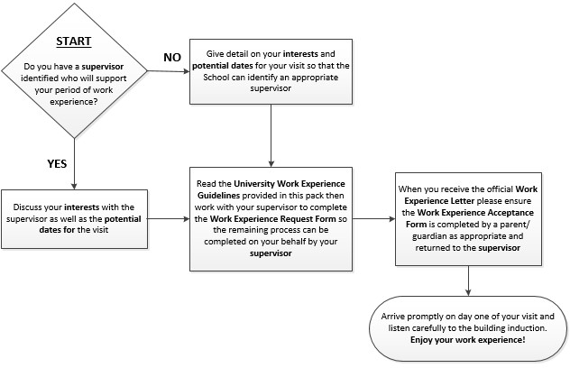

Work experience request form

|  |  |  |  |
| --- | --- | --- | --- |
| **Supervisor**  *(leave this blank if unknown when first making contact with us)* | | | |
| Full name: |  | | |
| Title: |  | | |
| School: |  | | |
| Please conﬁrm you will: | take responsibility as the named supervisor | Yes | No |
|  | complete a Risk Assessment | Yes | No |
|  | ensure safeguarding measures are addressed | Yes | No |
|  | notify the Insurance Oﬃce | Yes | No |
|  | submit all the work experience details to [deanmed@soton.ac.uk](mailto:deanmed@soton.ac.uk) for their records | Yes | No |
| Signed: |  | | |
| Date: |  | | |

|  |  |
| --- | --- |
| **Student details** | |
| Full name: |  |
| School/College/Home-school: |  |
| Local education authority or  sponsoring body: |  |
| Work experience dates requested: |  |
| Age at the time of work experience: |  |
| Have you disclosed any disabilities or learning needs which may need reasonable adjustments? If yes, please give us further details. |  |
| What Schools or fields are you interested in? |  |
| Why do you want to do work experience with us? |  |

|  |  |
| --- | --- |
| **Head of School approval**  *(Please include all details if more than one Head of School needs to approve)* | |
| Full name: |  |
| Title: |  |
| Signed: |  |
| Date: |  |

|  |  |
| --- | --- |
| **Dean approval** | |
| Signed: |  |
| Date: |  |